Project Design Phase
Solution Architecture

Date | 19 Febraury 2026
Team ID | LTVIP2026TMIDS41894
Project Name | Plugging into the Future: An Exploration of Electricity Consumption Patterns Using Tableau
Maximum Marks | 4 Marks

Solution Architecture:
Solution architecture is a complex process – with many sub-processes – that bridges the gap between business problems and technology solutions. Its goals are to:
- Find the best tech solution to solve existing business problems.
- Describe the structure, characteristics, behavior, and other aspects of the software to project stakeholders.
- Define features, development phases, and solution requirements.
- Provide specifications according to which the solution is defined, managed, and delivered.

Example - Solution Architecture Diagram:

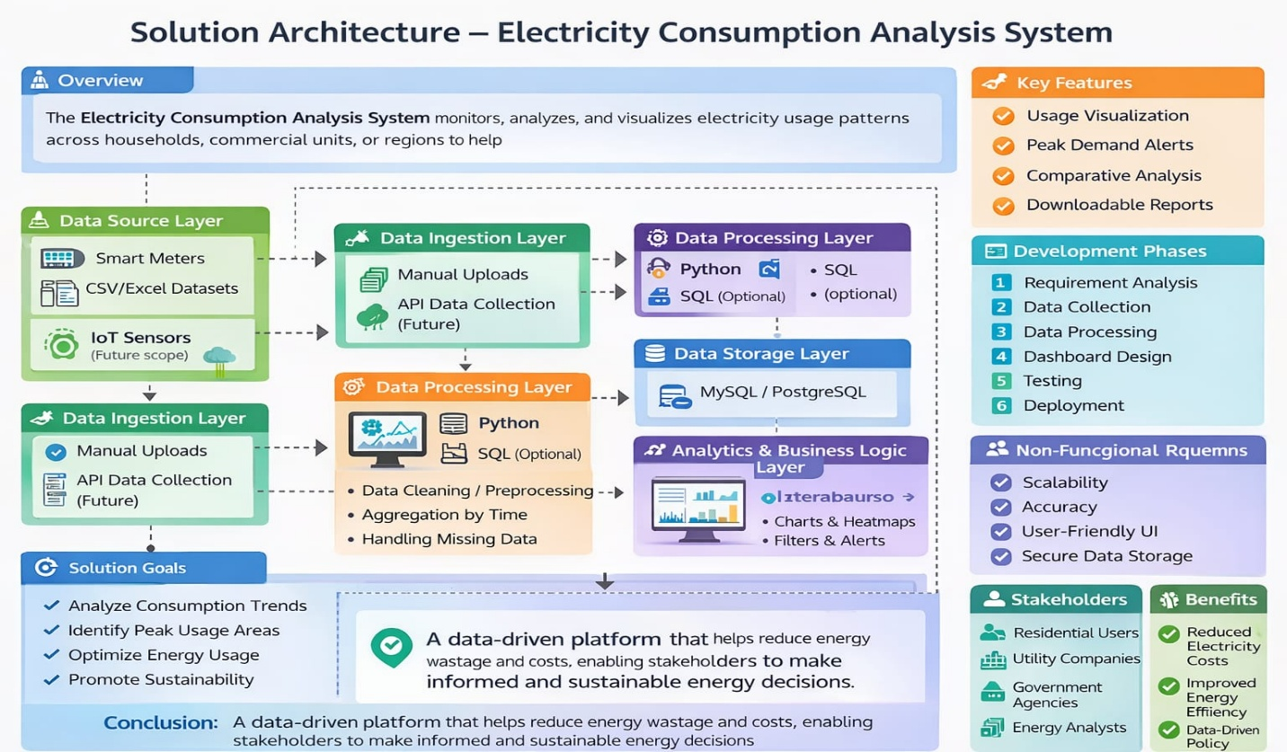
A streamlined architecture that transforms raw electricity data into meaningful insights, enabling users and utilities to optimize energy consumption effectively.

